

SIX WEEK SUMMER TRAINING REPORT
on
DATA SCIENCE & MACHINE LEARNING
(June – July 2022)

Submitted by
RANJITH SK
Registration Number: 12007594

Under the Guidance of
PRANAY SHARMA
(Instructor for the course/project at IBM(All Soft Solutions))

School of Computer Science & Engineering
Lovely Professional University, Phagwara

DECLARATION

I hereby declare that I have completed my six weeks summer training at All Soft Solutions(IBM), Punjab through online classes from June 6 to July 8 under the guidance of Pranay Sharma. I declare that I have worked with full dedication during this training and the completion of this course/project partially fulfil the requirements for the award of degree of B.Tech Computer Science Engineering (Hons).
Specialization: Data Science

RANJITH SK
Registration Number: 12007594

Date: 15/07/2022
Expert from IBM/All Soft Solutions(Teacher): Pranay Sharma

ACKNOWLEDGEMENT

I would like to express my respect and gratitude to the teachers at Lovely Professional University and the training coordinators for providing this opportunity to do this program and project regarding Data Science & Machine Learning.

I would also like to extend my gratitude to Pranay Sharma(Teacher from IBM/All Soft Solutions) who helped us by giving guidance and support all through the program and also in completing the project.

The success and final outcome of this project required a lot of guidance and assistance from my instructor and my friends, and I am extremely fortunate to have got this along the completion of my project work. Whatever I have done is only due to such guidance and assistance and I would not forget to thank them.

SUMMER TRAINING CERTIFICATE

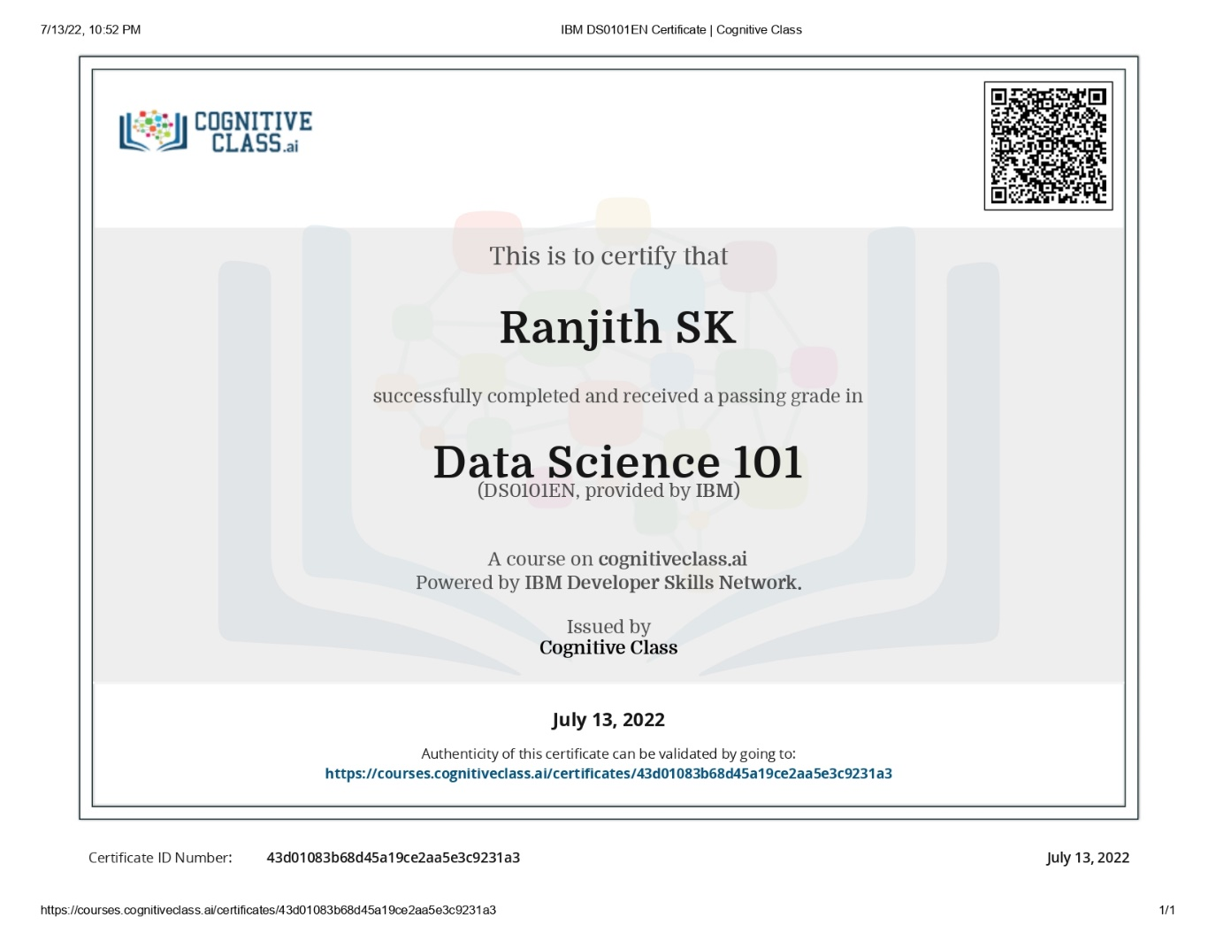

Certificate issued by Cognitive class after completion of the course and test on DATA SCIENCE 101 (IBM)

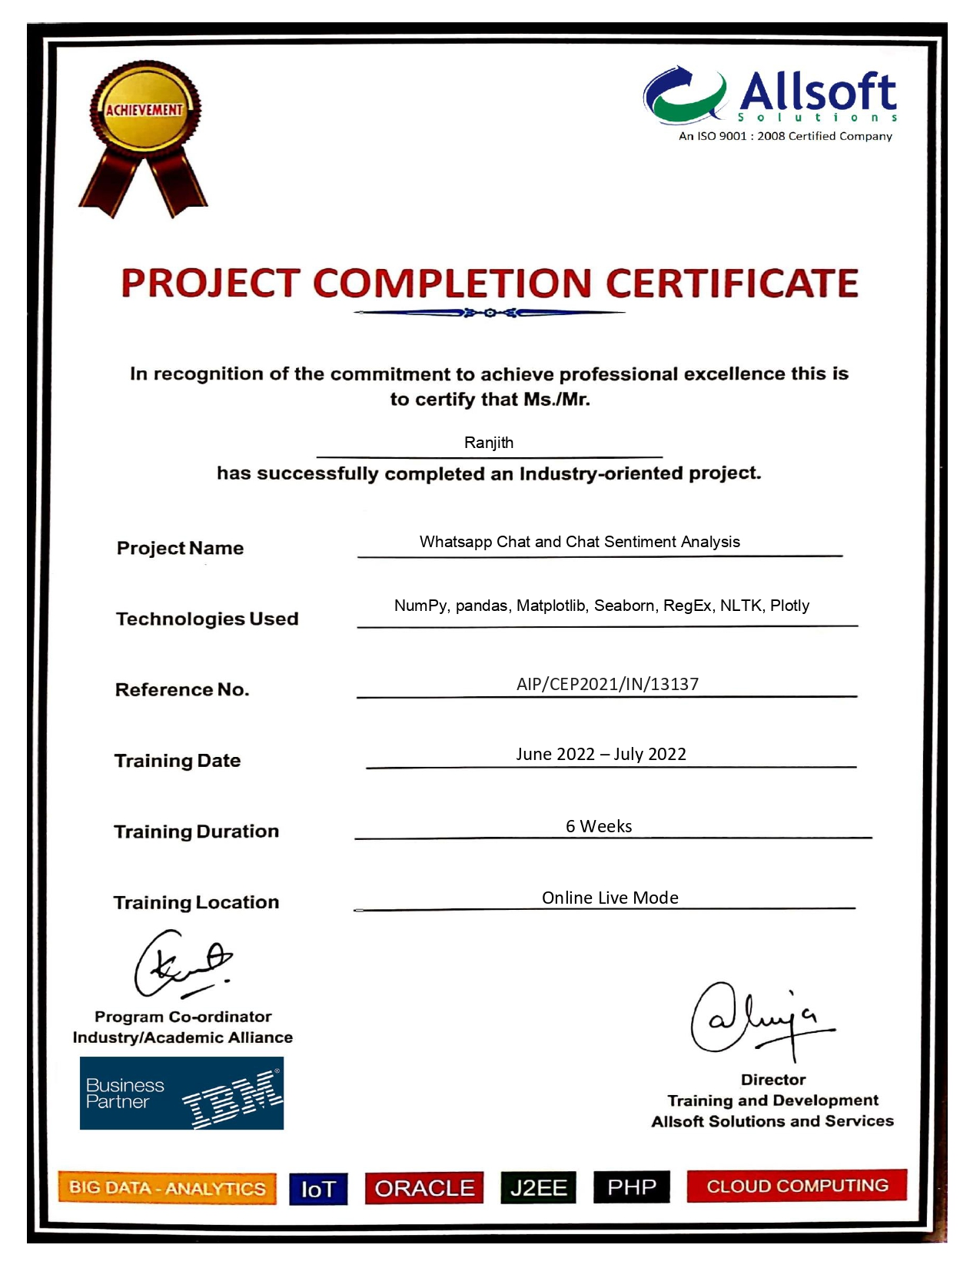
Certificate issued by All Soft Solutions(IBM) after the completion of the course and project WhatsApp Chat and Chat Sentiment Analysis

S.No | TABLE OF CONTENTS | PAGE
1. | Introduction | 1
2. | Technology Learnt | 2
3. | Project Objective | 2
4. | Idea of the Project | 3
5. | Project Architecture | 3
6. | System Implementation | 5
7. | Survey regarding project | 6
8. | Advantages of this Project | 7
9. | Project Implementation | 8
10. | Reason for choosing this Technology/Project | 22
11. | Conclusion | 22
12. | Learning Outcome | 23

INTRODUCTION

The project I have completed is based on the analysis of WhatsApp chat and chat sentiment; I have tried my best to make the complicated process of chat analysis as simple as possible using the necessary requirements. I have tried to design the project in such a way that user may not have any difficulty in using this package & further expansion is possible without much effort. Even though I cannot claim that this work to be entirely exhaustive, the main purpose of our work is Chat analysis which is the investigation and modelling of a specific WhatsApp chat’s thorough worktime and analytics, so that we can save our time and manage our worktime and activities.
The most used and efficient method of communication in recent times is an application called WhatsApp. WhatsApp chats consists of various kinds of conversations held among group of people. This chat consists of various topics. This information can provide lots of data for latest technologies such as machine learning. The most important thing for a machine learning model is to provide the right learning experience which is indirectly affected by the data that we provide to the model. This project aims to provide in depth analysis of this data which is provided by WhatsApp. Irrespective of whichever topic the conversation is based our developed code can be applied to obtain a better understanding of the data. The advantage of this project is that is implemented using simple python modules such as pandas, matplotlib, seaborn and sentiment analysis which are used to create data frames and plot different graphs, where then it is displayed in detail, which is efficient and less resources consuming algorithm, therefor it can be easily applied to largest dataset.
This project is based on data analysis and processing. The first step in implementing a machine learning algorithm is to understand the right learning experience from which the model starts improving on. Data pre-processing plays a major role when it comes to machine learning. To make the model more efficient we need lots of data, so we turned our focus primarily on one of the largescale data producers owned by Facebook which is nothing but WhatsApp. WhatsApp claims that nearly 55 billion messages are sent each day. The average user spends 195 minutes per week on WhatsApp and is a member of plenty of groups. With this treasure house of data right under our very noses, it is but imperative that we embark on a mission to gain insights on the messages which our phones are forced to bear witness to.
TECHNOLOGY LEARNT
Data Science
Module 1 - Defining Data Science
  - What is data science?
  - There are many paths to data science
  - Any advice for a new data scientist?
  - What is the cloud?
Module 2 - What do data science people do?
  - A day in the life of a data science person
  - Data science tools and technology
Module 3 - Data Science in Business
  - How should companies get started in data science?
  - Recruiting for data science
Module 4 - Use Cases for Data Science
  - Applications for data science
Module 5 - Fun with Data Science
  - Things data science people say

Python for Data Science
Module 1 - Python Basics
- Types
- Expressions and Variables
- String Operations
Module 2 - Python Data Structures
- Lists and Tuples
- Sets
- Dictionaries
Module 3 - Python Programming Fundamentals
- Conditions and Branching
- Loops
- Functions
- Objects and Classes
Module 4 - Working with Data in Python
- Reading files with open
- Writing files with open
- Loading data with Pandas
- Working with and Saving data with Pandas
Module 5 - Working with NumPy Arrays
- NumPy 1D Arrays
- NumPy 2D Arrays

PROJECT OBJECTIVE
In this decade the upcoming technologies are mainly dependent on data. This data can only be obtained if there is some research applied on the context of the requirements of the project/tool. Since a lot of machine learning enthusiasts develop models which helps solve multiple problems the requirements of appropriate data are very large scale this project aims to provide a better understanding towards various types of chats. This analysis proves to be better input to machine learning models which essentially explore the chat data. These models require proper learning instances which provides better accuracy for these models. Our project ensures to provide an in-depth exploratory data analysis on various types of WhatsApp chats.

IDEA OF THE PROJECT
WhatsApp chat analysis is a statistical analysis project for WhatsApp chats. Working on the chat files that can be exported from WhatsApp it generates various plots showing, for example, which another participant a user responds to the most. We propose to employ dataset manipulation techniques to have a better understanding of WhatsApp chat present in our phones.

PROJECT ARCHITECTURE
The project architecture shows the general architecture of this project. This includes, data collection stage, the data input state, data transformation, data exploration and data visualization. The data collection stage is shown further down while the data input, data transformation, data exploration and data visualization are handled by Python and its libraries.
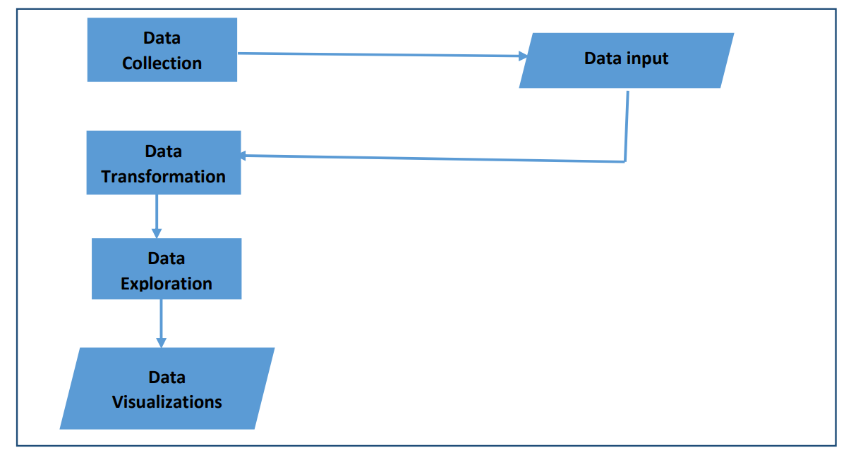

- Data Collection Stage
This stage involves the point where the WhatsApp data is collected. This was done by visiting the chat group to be analyzed, to export the WhatsApp data file that was used. The procedures involved, visiting the WhatsApp group page, clicking on the settings, select export data and then select either add media or without media. This simply means to know whether you intend to export the file with the media or not. Note that exporting with the media, will lead to use of larger volume of data and waste of time for data collection. The below figure will be a brief illustration of the steps involved in the data collection.
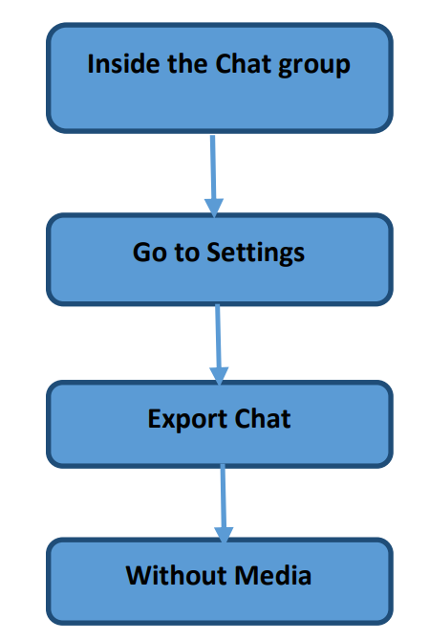

SYSTEM IMPLEMENTATION
Python: It is an interpreted, high-level general-purpose programming language. Created by Guido Van Rossum and first released in 1991. Its language constructs and objects-oriented approach aim to help programmer with clear, logical code for small and large-scale tools. Python is used for web development (server-side), software development, mathematics, it can be used alongside software to create workflows, it can connect to database systems, it can also read and modify files, it can be used to handle big data and perform complex mathematics and can be used for rapid prototyping, or for production-ready software development.
Pandas: This is an open-source Python libraries which is mainly used in Data Science and machine learning subjects. This library provides analysis tool for data manipulation, using its data structures this are used for analyzing data for manipulating time series analysis and numerical data.
NumPy: NumPy can be name come from Numeric Python, it is a data analysis library for Python that contains various numerical functions and methods for numerical analysis and having multi-dimensional array objects and to process these arrays contains collection of routines.
Matplotlib: Matplotlib is easy to use and an amazing visualizing library in Python. It is built on NumPy arrays, and it work with the broader SciPy stack and consists of several plots like pie, line, bar, graph, scatter, histogram, etc. In this project, Matplotlib is used for various visualizations for analysis of WhatsApp chats. Visualizations like bar charts, line charts, pie charts are used.
Seaborn: Seaborn is a library mostly used for statistical plotting in Python. To make statistical plots more attractive it provides beautiful color palettes and default styles. In this project, Seaborn is used for heatmap visualization for showing 24 hours with 7 day with different scale of color for getting hour with max to min messages.
NLP: In this project, Features of NLP are used like Parsing Text, Eliminating stop words and Analyzing Text. Parsing text is used for splitting messages into words for analysis like total words and mostly used words. A file is used that contains all stop words which is given to the python program to show meaningful words only by eliminating all stop words. Text analysis is used to identify how many media are shared; how many links are shared.

SURVEY
As a demo Survey analysis on the usage and Impact of WhatsApp Messenger, Various Studies and analysis has been done on the usage and impact of WhatsApp. Some of these studies are for finding the impact of WhatsApp on the students and some are based on for the public in a local region.
In a study of southern part of India was conducted on the age group of between 18 to 23 years to investigate the importance of WhatsApp among youth. Though this study, it was found that students spent 8 hours per day on using WhatsApp and remain online almost 16 hours a day. All the respondents agreed that they are using WhatsApp for communicating with their friends. They also exchange images, audio and video files with their friends using WhatsApp. It was also proved that the only application that the youth uses when they are spending time on their smart phone is WhatsApp. Methods used in this survey is to analyze the intensity of WhatsApp usage and its popular services and to identify the degree of positive or negative impacts of using WhatsApp.

ADVANTAGES OF WHATSAPP CHAT ANALYSIS PROJECT
• Works on all devices.
• Shows based on WhatsApp chat file.
• Shows different visualizations.
• Total Messages.
• Total words.
• Media shared.
• Link shared.
• Monthly timeline.
• Most busy day.
• Most busy month.
• Weekly activity.
• Most busy users.

IMPLEMENTATION
WHATSAPP GROUP CHAT ANALYSIS
### Importing libraries

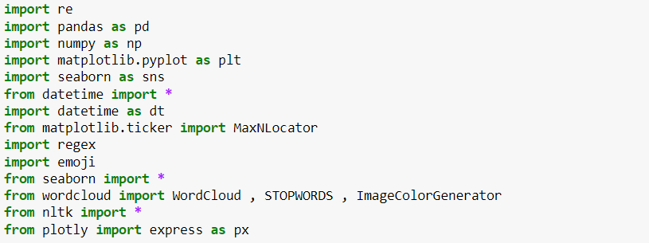

### Extracting date from chat file

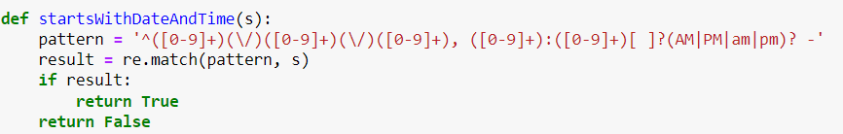

### Regex pattern to extract username of Author

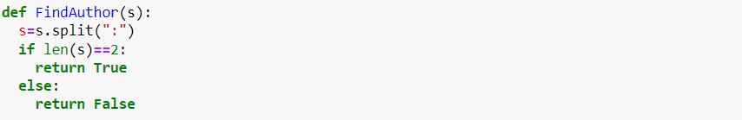

### Extracting Date, Time, Author, and message from the chat file

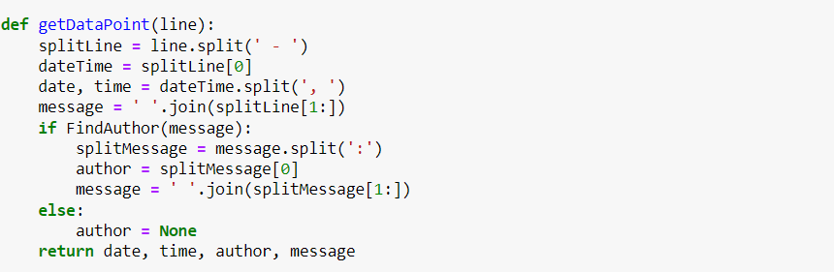

### Finally creating a data frame and storing all data inside that data frame

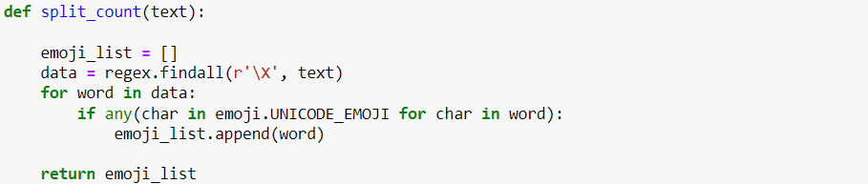

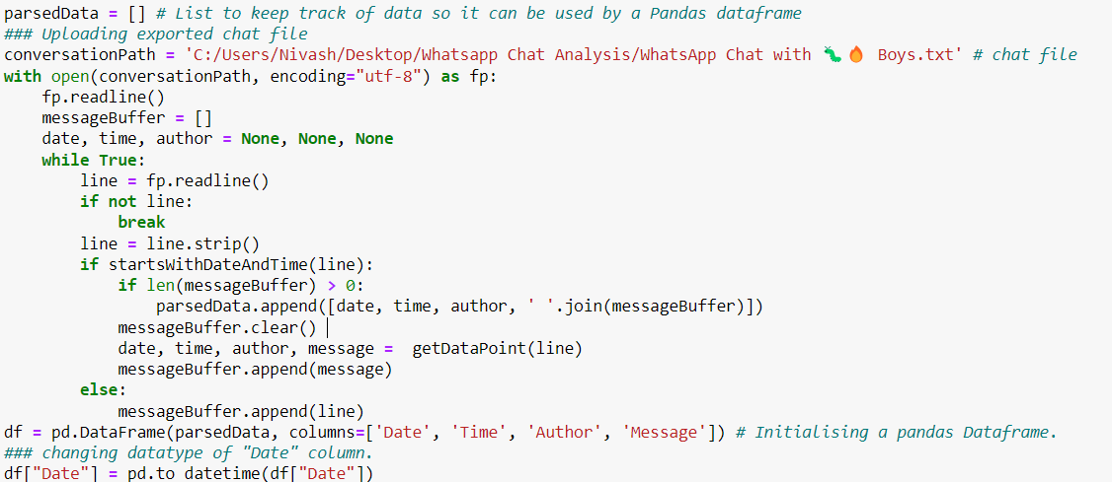

### Checking head part of Dataset

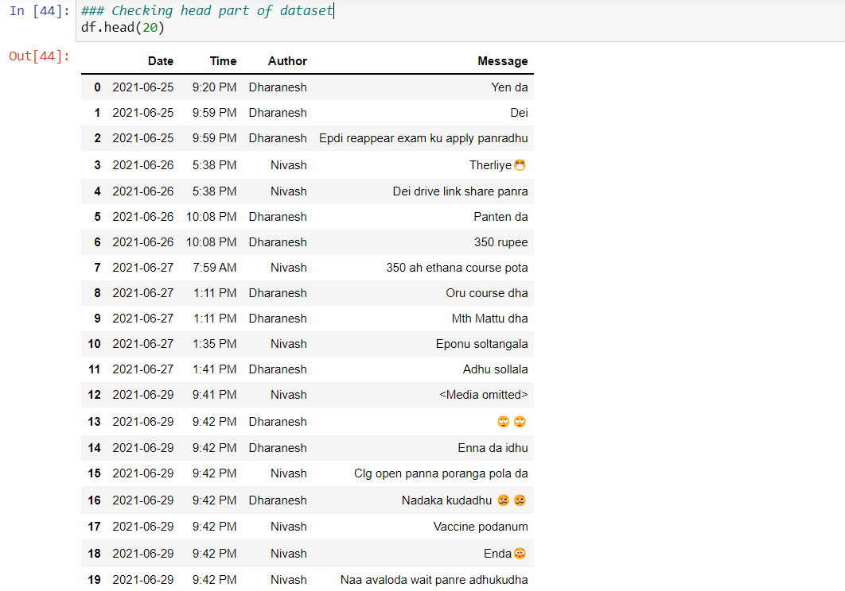

### Checking shape of Dataset

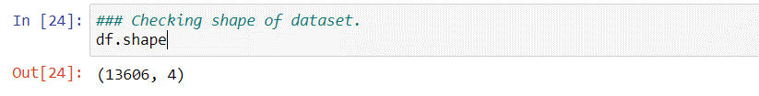

### Checking information of Dataset
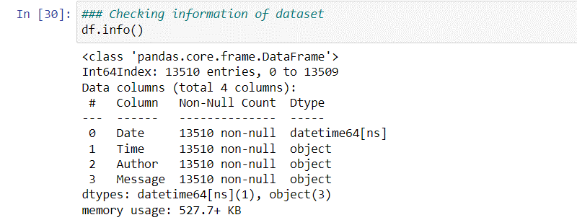

### Dropping Nan values
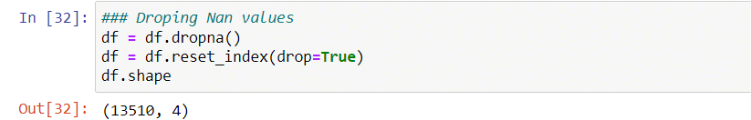

### Checking no. of authors of group
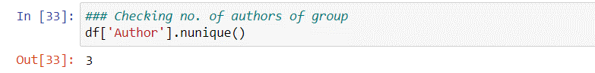

### Checking authors of group
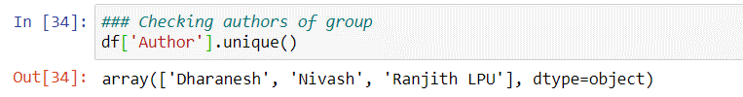

### Total Number of Messages
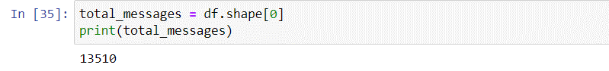
### Adding one more column of “Day” for better analysis, here we use datetime library which help us to do this task easily

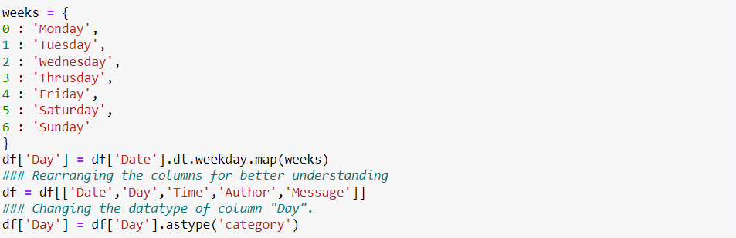

### Updated Dataset

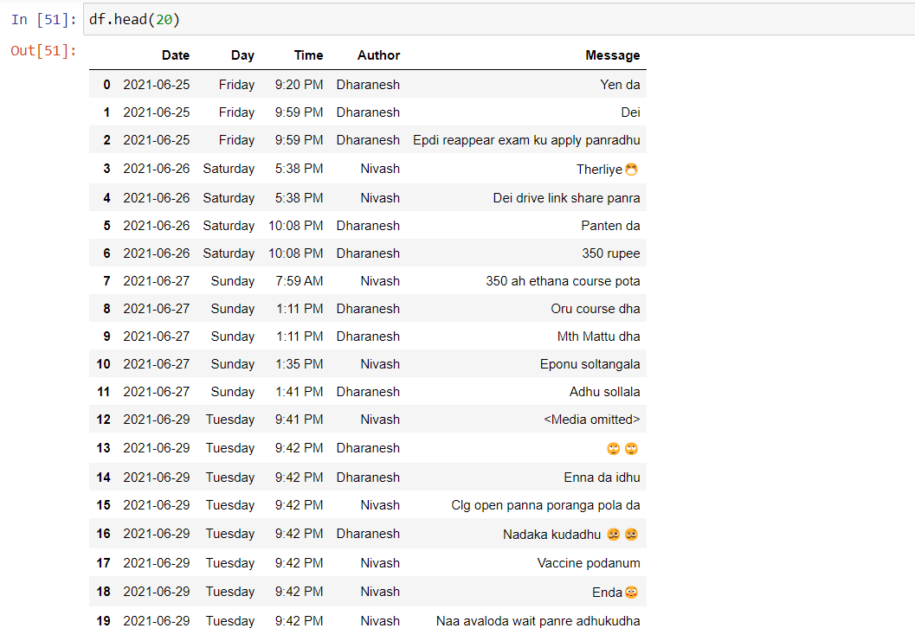

### Function to count number of links in dataset, it will add extra column and store information in it.

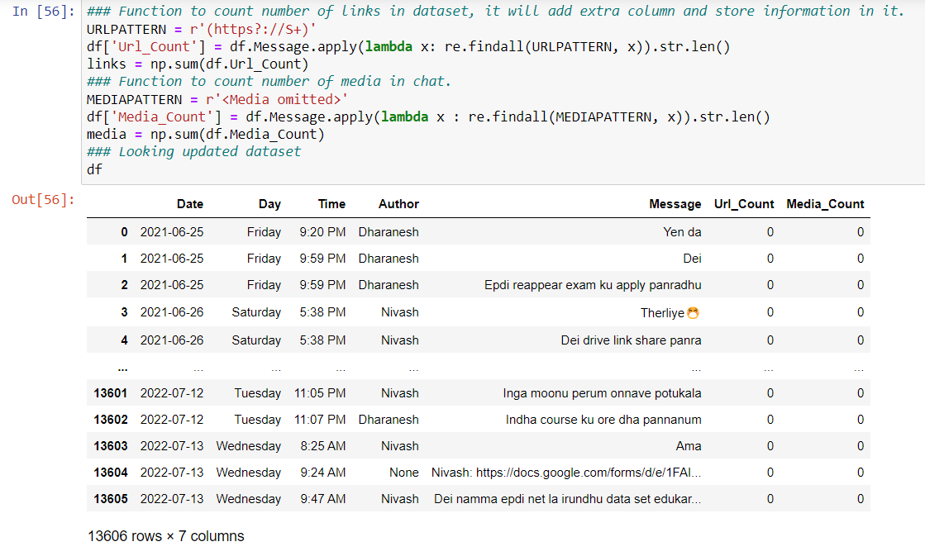

### Group Chatting Stats
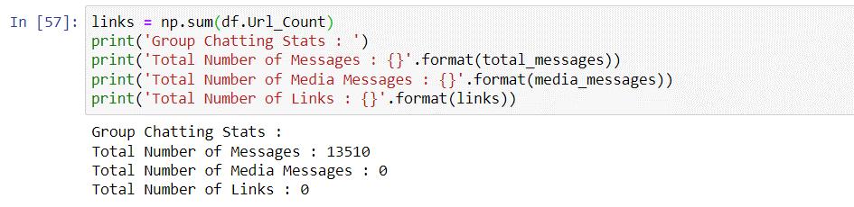

### Creates a list of unique Authors
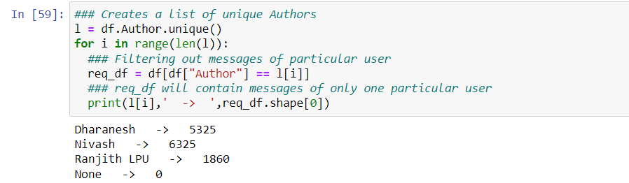
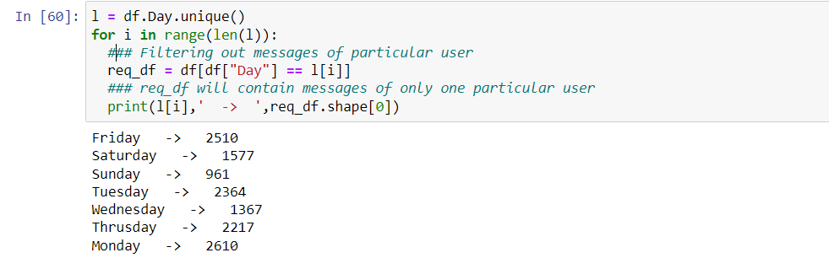

### Most Active Author in the Group

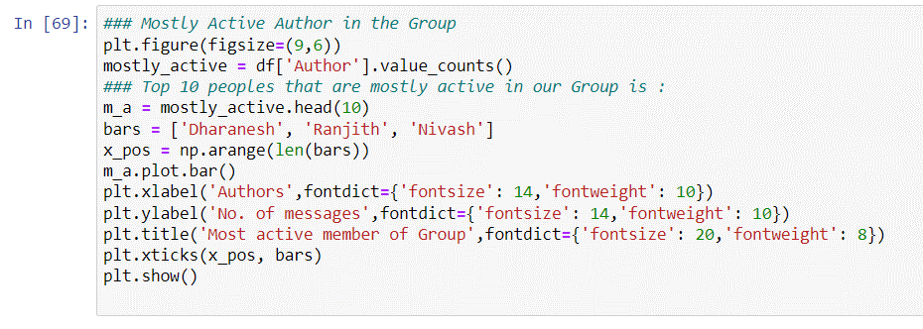

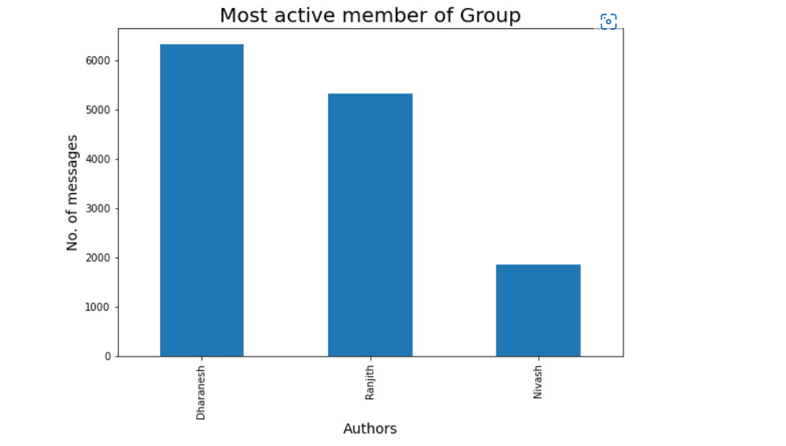

### Most Active day in the Group

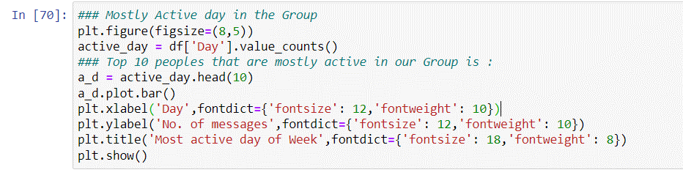

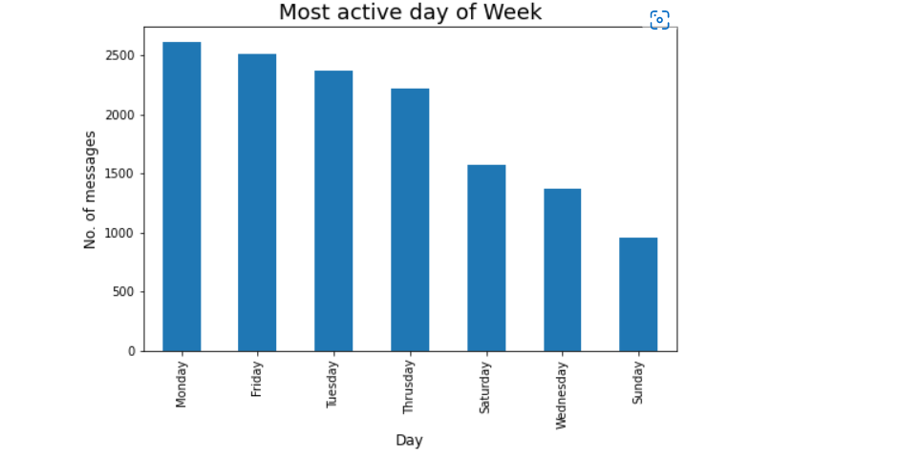

REASON FOR CHOOSING THIS PROJECT

I chose ‘WhatsApp Chat Analysis’ as my project because, in our day-to-day life we greatly indulge in the usage of social media such as WhatsApp, Instagram, Twitter and so. As such by choosing this as my topic while I complete my project with regards to the course program, I wanted to learn how WhatsApp affect our daily life. By learning the time period spent(chat analysis) in WhatsApp, we can greatly adjust our time management with other respective work and activities in our daily. Hence, this project helps us both in developing our Python programming language skill but also helps us in our daily life with regards to time management.

CONCLUSION OF THE PROJECT

It is concluded that WhatsApp plays a vital role in lives of students and professionals. We can argue for days stating this is a breach of privacy to analyse a person chat and process the emotions but when we see the brighter side of the project ,we can help people develop their character by helping them suggesting proper vocabulary to guide them in a proper path to reach a sustainable position with the other end person in terms of relations, business agreements and many more . It can be said that the capabilities of the WhatsApp application and the power of the python programming language in implementing whatever network data analysis intended, cannot be overemphasized. This work was able to discuss the WhatsApp application and its libraries, to create an analysis of a WhatsApp group chat and chat sentiment while visually representing the top users in the chat groups. The project was done with Python and the Python libraries that were implemented includes, NumPy, Pandas, Matplotlib and Seaborn. At the end of the work the expected results were obtained, and the analysis was able to show the level of participation of the various individuals on the given WhatsApp group.

LEARNING OUTCOME FROM THE TRAINING

- In this summer training, I completed a course on “Data Science”. The reason I chose this course is because I have interest in the field of Data Science. My specialization in the coming years is Data Science. So, to have completed this introductory course is a good start. Though I have prior experience in Python it was clearer to revise them with the basics and learn other intermediate parts while learning.

- It was my first-time learning, Machine Learning and it was fun learning and knowing how every field I have interest in like, Data Science, Machine Learning, Programming are correlated. And it was also helpful to me in many ways, like showing us how data science and machine learning were related to real life problems.

- I can clearly say that I am satisfied with the training as I have covered what I wanted to know about data science and machine learning before going through the specialization class next semester.

